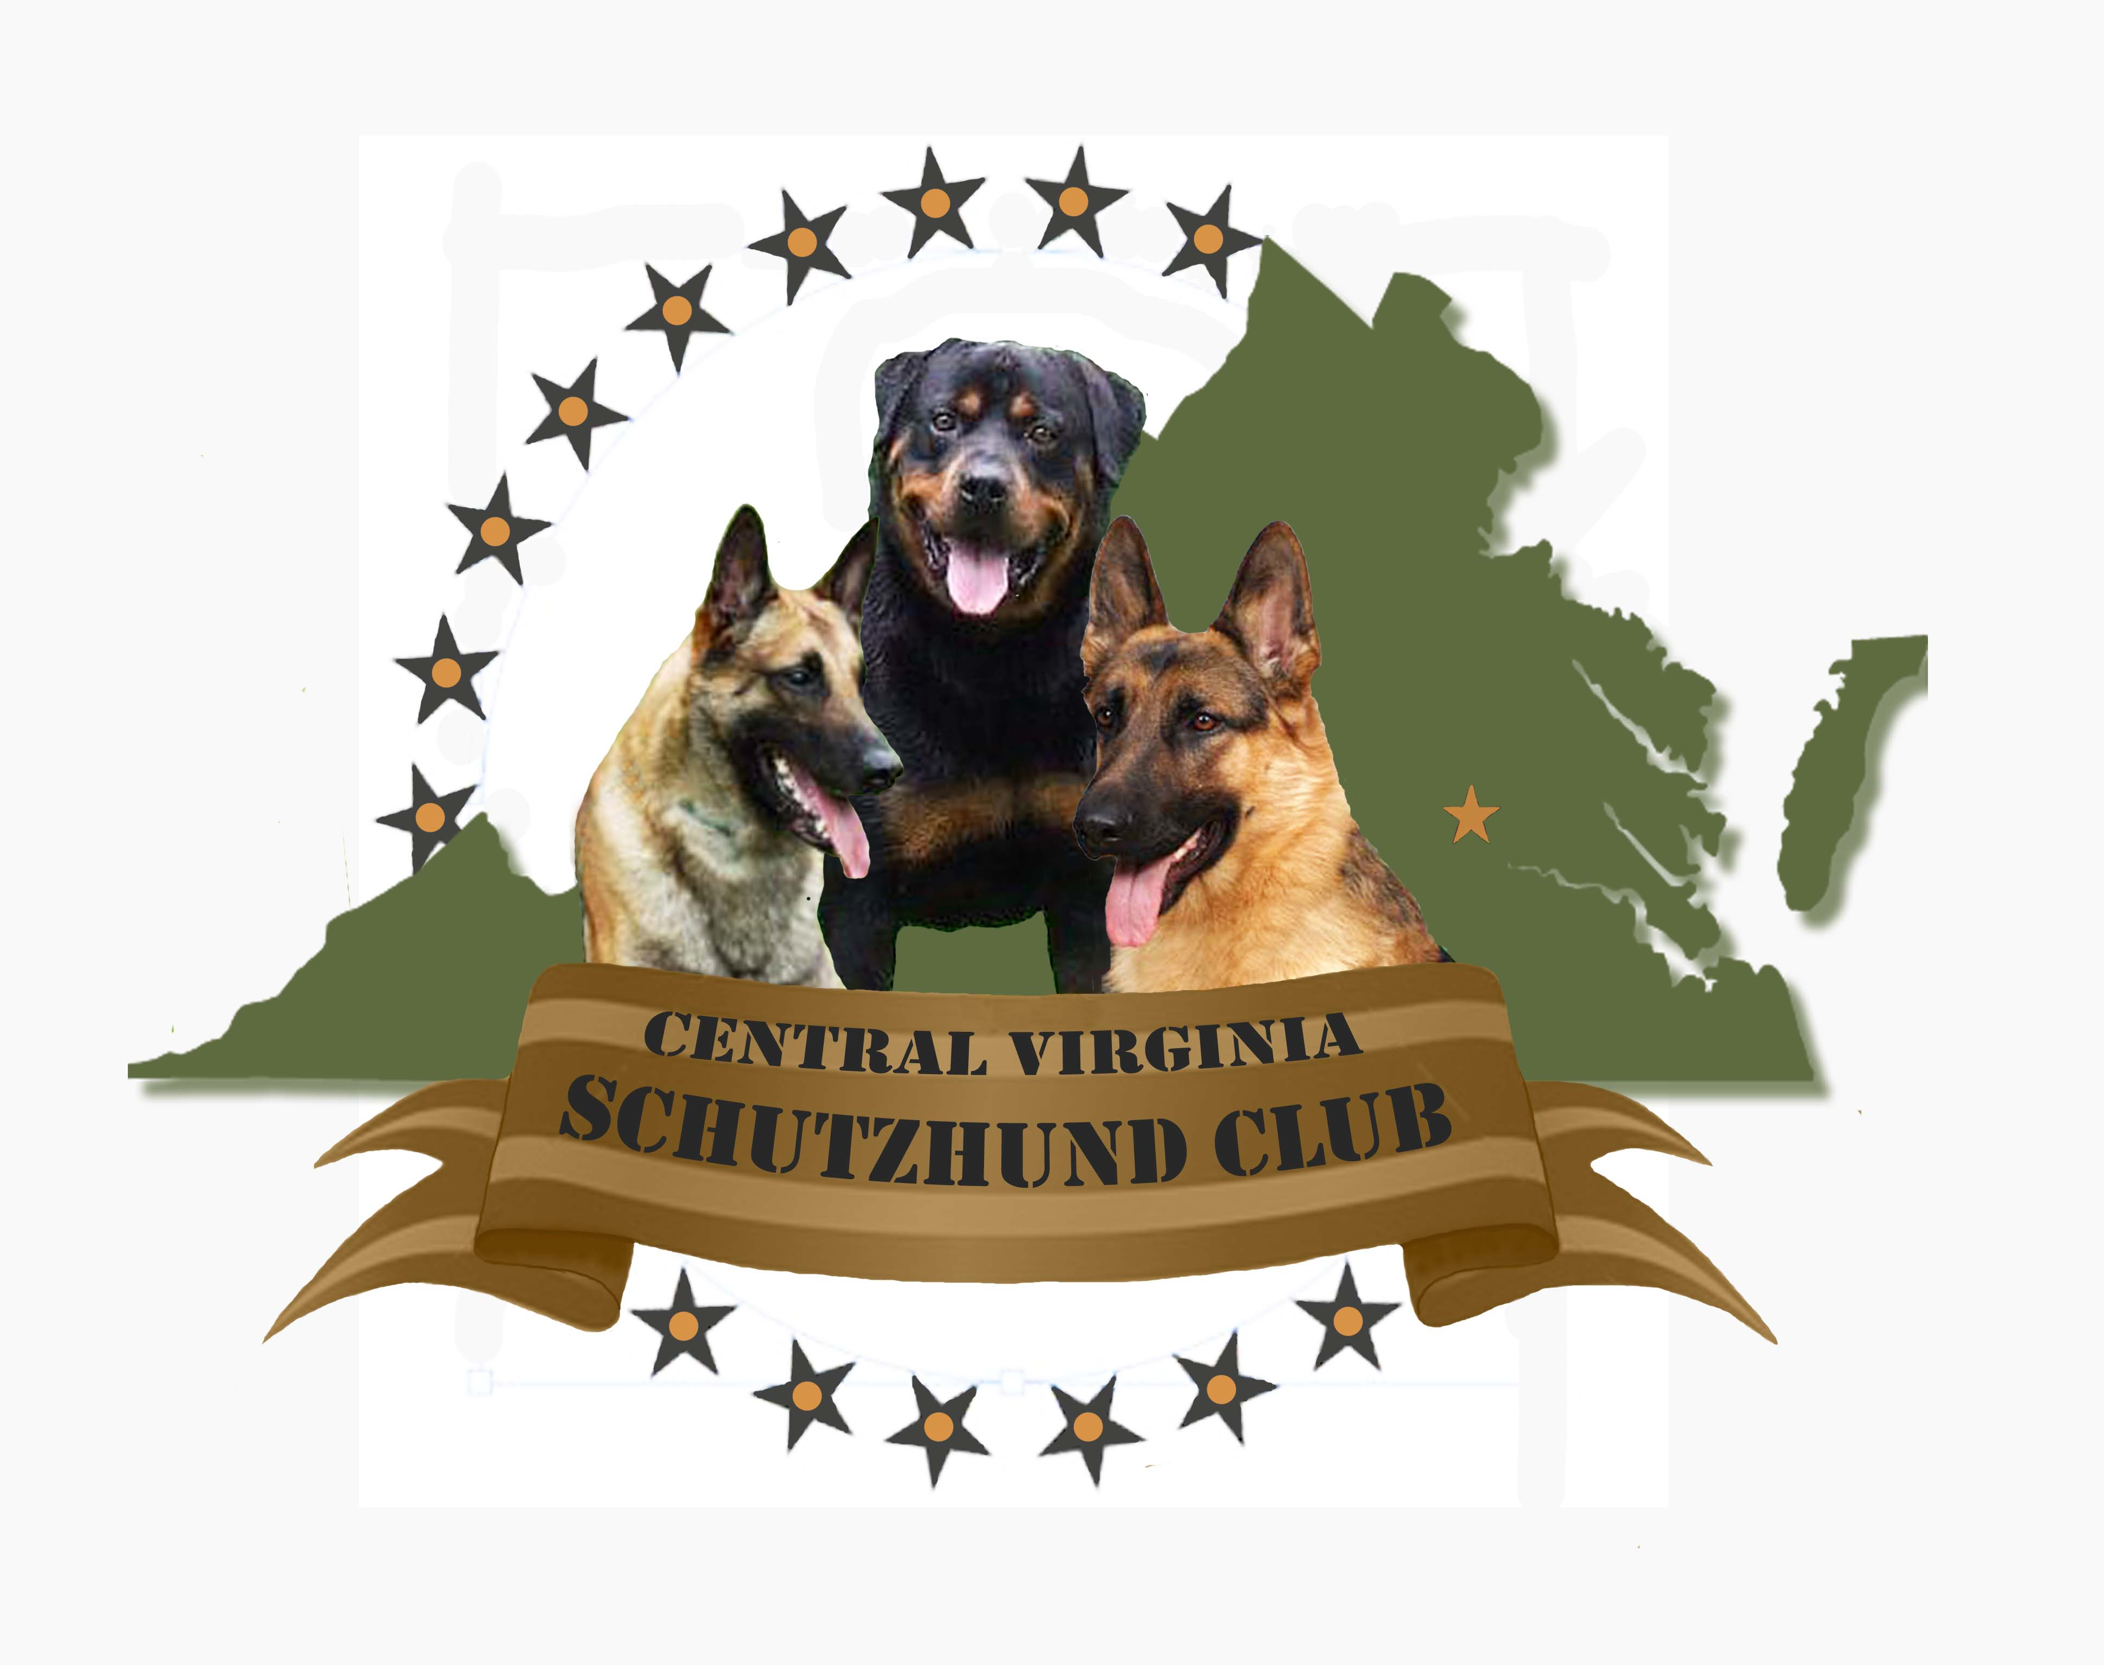Application date: _________________________________

Central Virginia Schutzhund Club MEMBERSHIP APPLICATION

Welcome to The Central Virginia Schutzhund Club. All information in this application will be treated confidentially. Please contact our President Jacob Pope at 804-387-1950 if you have any questions or need assistance with applying.

Personal Information

ADULT APPLICANT
Male Female
Title  Full Name | Mr. Mrs. Ms. Other________
By what first name to you wish to be addressed (if different from above)?
Date of Birth / SSN
Contact Information

How would you like your name to appear on our website? We will do our best to accommodate your request within system capabilities.

Name(s):_______________________________________________________________________________________

Home address: __________________________________________________________________________________

City: _________________________________________________________ State: ___________________________

Zip: ________________________________________Phone: ____________________________________________

Cell Phone : _________________________________ Email 1: ___________________________________________
.

Other Applicant Information
Occupation/Title
Schutzhund Goals
Other interests

Dog (s) Information
Name | Call Name | Breed | Color | Age | Gender | Titles

Emergency Contact Information

Name: ______________________________________________________________

Phone: ________________________________ Relationship: __________________________

Member Agreement:
By submitting this form I understand that I am fully responsible for the actions of my dog and I agree to keep my dog properly restrained and under control between and during all exercises. I will provide a suitable cage or crate upon arrival at the training field. I will not hold this club; it's officers or members responsible for injury or damage that may occur to me, my dog, or property resulting from any club activities. I understand that my participation in this club is at my own risk and any risk to my dog. I understand that the training of my dog is for the purpose of the sport. I will provide the necessary personal insurance to cover the possible actions of my dog. I agree to abide by the constitutions, by-laws and decisions of the offices of Central Virginia Schutzhund Club.

Applicant: I, ________________________________, am applying to become a member of the CVSC. Signature_____________________________________________________ Date________________

